

CSUC201 Fundamentals of Data Structures and Algorithms 25DCE118

FACULTY OF TECHNOLOGY AND ENGINEERING

DEVANG PATEL INSTITUTE OF ADVANCE TECHNOLOGY

AND RESEARCH

DEPARTMENT OF COMPUTER ENGINEERING

A.Y 2026 – 27 Semester – 3

LAB MANUAL

CSUC201 Fundamentals of Data Structures and Algorithms

DEPSTAR 1
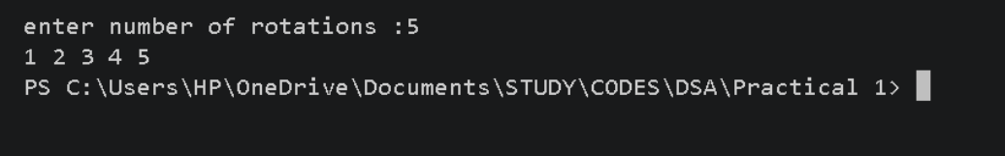
CSUC201 Fundamentals of Data Structures and Algorithms 25DCE118

Practical 1: Array Operations: Traversal, Rotation, and Frequency Analysis

Problem 1 — Bakery Display Row Rotation

Question :

A bakery prepares n items every morning and places them in a display row. At the end of each hour, the leftmost item is moved to the rightmost position to make room for fresh stock at the front. Given the initial row and the number of hours h, print the final display order. Describe the approach you used. How does it behave whenhisverylarge,say10million?Isthereawaytogetthecorrect result without performing the operation h times?

For Code :

https://github.com/kvvaghasiya49/FDSA/tree/6fb2f463bf1f58ac 408ada5ca8ffdaa64bc82087/DSA

DEPSTAR 2
CSUC201 Fundamentals of Data Structures and Algorithms 25DCE118

Challenges Faced:

At first I wrote the code to rotate the array one step at a time, h times, using a loop that removes the first element and adds it at the end. It worked fine for small values of h, but when h was very large (like 10 thousand), the program became very slow because it was doing the same rotation again and again unnecessarily. Then I know that rotating the array by its own size (n) brings it back to the same array, so most of those rotations were being wasted.

Learning Outcomes:

1. I learned that a correct solution can still be slow if it repeats unnecessary work.

2. I understood that rotating an array by h positions is the same as rotating it by h % n.

3. I learned a faster way to rotate the array without looping h times, using the modulo operator.

4. This helped me understand why finding a smarter approach matters, especially when the input size is large.

DEPSTAR 3
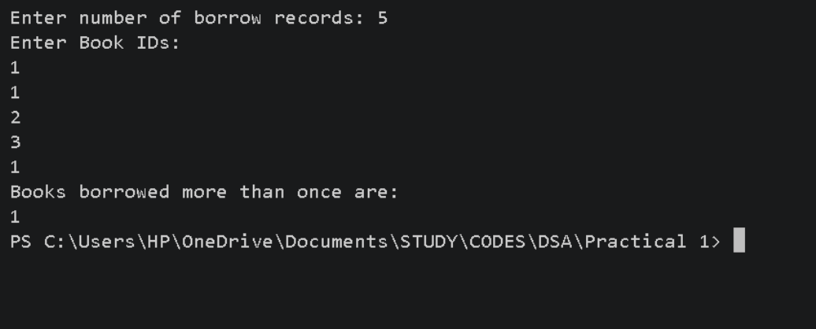
CSUC201 Fundamentals of Data Structures and Algorithms 25DCE118

Problem 2 — Library Duplicate Book IDs .

Question : A library issues books to students and records each book's ID every time it is borrowed. At the end of the month, the librarian wants to find all books that were borrowed more than once, as those need priority restocking. Given the borrowing log, print all such book IDs. Describe the approach you used. How many times does your solution scan the data? If the library had 100,000 borrow records, would your approach still be practical? Can you think of a way that requires fewer passes?

For Code :

https://github.com/kvvaghasiya49/FDSA/tree/6fb2f463bf1f58ac40 8ada5ca8ffdaa64bc82087/DSA

Output :

DEPSTAR 4
CSUC201 Fundamentals of Data Structures and Algorithms 25DCE118

Challenges Faced:

My first solution used two nested loops to find duplicate book IDs — for every index, I checked backward to see if it was already printed, and then checked forward to see if it repeats later. This worked for small inputs but became very slow for large ones, since checking every element against every other element leads to about n² comparisons. For 100,000 records this meant around 10 billion comparisons, which was way too slow. It took me a while to realize that I didn't need to compare every pair of elements at all — I just needed a way to count occurrences quickly.

Learning Outcomes:

1. I learned that nested loops for this kind of problem can become extremely slow as input size grows.

2. I learned that going from O(n²) to O(n) makes a huge difference when the input is large.

3. This helped me understand why choosing the right data structure (like a hash map) can make a solution much faster and simpler.

DEPSTAR 5
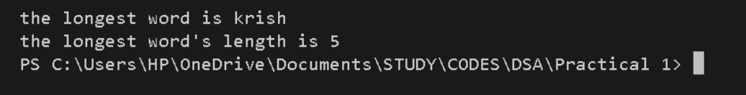
CSUC201 Fundamentals of Data Structures and Algorithms 25DCE118

Problem 3 — Longest Word in an Article

Question : A school newspaper editor wants to highlight the most impressive word from a submitted article on the front page. The word is chosen simply by length — the longest one wins. Given a sentence, print the winning word and how many letters it has. Describe the approach you used. What does your solution do when two words have the same length? Is that behavior intentional, and can you think of a way to handle it explicitly?

For Code :

https://github.com/kvvaghasiya49/FDSA/tree/6fb2f463bf1f58ac40 8ada5ca8ffdaa64bc82087/DSA

Output :

DEPSTAR 6
CSUC201 Fundamentals of Data Structures and Algorithms 25DCE118

Challenges Faced:

I used a stringstream to break the sentence into words one by one, and kept track of the longest word found so far by comparing each new word's length with the current longest. This part was straightforward, but I noticed a small issue — when two words have the same length (like "sample" and "string", both 6 letters), only the first one gets printed because I used strictly greater than instead of greater than or equal to. It took me a moment to realize this wasn't something I had planned for, it just happened naturally because of how the comparison worked.

Learning Outcomes:

1. I learned that using a stringstream is an easy way to split a sentence into words without manually handling spaces.

2. I understood how a single pass through the sentence (O(n)) is enough to find the longest word, without needing extra loops.

3. I learned that the choice between > and >= in comparisons can quietly decide how ties are handled, even if it wasn't intentional.

4. This made me realize that I should think about edge cases like ties beforehand, instead of noticing them by accident afterward.

DEPSTAR 7
CSUC201 Fundamentals of Data Structures and Algorithms 25DCE118

Key Questions / Analysis / Interpretation to be Evaluated During/After

Implementation

1. [Problem 1] The display order repeats itself after a certain number of hours regardless of

how large h gets. Without trying any specific example, explain why this repetition is

inevitable and what determines when it first repeats.

Ans : The array has only n possible arrangements when you rotate it (since each rotation just shifts elements, and after n shifts you're back to where you started). So no matter how large h is, once you rotate n times, the array becomes the same as the original. This means the pattern must repeat after every n hours, and it first repeats exactly when h = n.

2. [Problem 2] If the same book ID appears three times in the log, should it appear once or three times in your output? Does your solution handle this correctly, and how would you verify it?

Ans :

Itshouldappearonlyonceintheoutput,sincewejustwanttoknow which IDs areduplicates,not how many times.Mysolution handles this correctly because I use a hash map to count occurrences, and while printing, I only check if the count is greater than 1 — I don't print it multiple times. To verify this, I can test with an ID that appears 3 times and check that it shows up only once in the output.

DEPSTAR 8
CSUC201 Fundamentals of Data Structures and Algorithms 25DCE118

3. [Problem 3] The editor later decides that punctuation attached to a word (e.g. “hello,” or “great!”) should not count toward its length. How would this change your solution, and at which step would you handle it?

Ans :

If punctuation like commas or exclamation marks attached to a word shouldn't count, then before comparing the length of a word, I would need to remove any punctuation from it first. This should be handled right after extracting each word from the stringstream and before comparing its length with the current longest word, so the length calculated is only for the actual letters.

Faculty Remarks:

DEPSTAR 9

